` ARTIFICIAL INTELLIGENCE WITH PYTHON

ASSESSMENT

# NAME : SARANG RAMPAL

INSTITUTION: CHANDIGARH UNIVERSITY

PART 1:

QUESTION : SOLVE ALL THE 11 QUESTIONS OF PYTHON ASSIGNMENT:

1.Take a list of elements from user and find square root of each number in the list and store it in another list and print it.

SOLUTION:

LIST1=[]

LIST2=[]

n=int(input(“enter no. of elements:”))

for i in range(0,n):

ele=int(input())

LIST1.append(ele)

LIST2.append(LIST1[i]**0.5))

print(*LIST2)

2.Write a function which prints all the number divisible by 3 and 5.

SOLUTION:

def div(number):

for i in range (number):

if i%3==0 and i%5==0:

print (i,end= “ ”)

input(number)

div(number)

3.WAP IN PYTHON TO CHECK WHETHER A GIVEN LETTER IS VOWEL OR CONSONANT.

SOLUTION:

ch = input(“Enter a character : ”)

if(ch == ‘A’ or ch == ‘E’ or ch == ‘I’ or ch == ‘O’ or ch == ‘U’ or ch == ‘a’ or ch == ‘e’ or ch == ‘i’ or ch == ‘o’ or ch == ‘u’):

print(ch, “is a vowel”)

else:

print(ch, “is a consonant”)

4.Calculate the distance between any two characters given by user.

Solution :

def dist(a,b)

distance = ord(strtolower(a) – ord(strtoupper(b))

print(distance)

a = chr(input(“enter first character : ”))

b =chr( input(“enter second character : ”))

dist(a,b)

5.Write a function which returns the number of vowels present in the given string

Solution:

def count (s):

c = 0

v = set (“aeiouAEIOU”)

for alphabet in s:

if alphabet in v:

c = c+1

print (c)

s =str( input(“enter a string : ”))

count(s)

6.Print all the alphabets using loop and ascii code

Solution:

print(“ All the alphabets are”)

for i in range(65,91):

print(chr(i),end = ‘ ’)

for i in range(97,123)

print(chr(i),end = ‘ ’)

7.Write a program to find sum of all even numbers of the list

Solution :

Nlist = []

sum = 0

n = int(input(“enter no. of elements”)

for i in range(1,n+1):

ele = int(input(“ enter”i“ element”))

Nlist.append(ele)

for j in range(n):

if(Nlist[j]%2 == 0):

sum = sum + Nlist[j]

print(sum)

8.Write a program to print the squares of all the numbers , except for factors of 3

Solution :

n = int(input(“ enter no. of elements ”)

print(“the square of elements except factors of 3 is ”)

for i in range(1,n+1):

if( i == 1 or i == 3):

print(“ ”)

else :

print ( i*i)

9.Take 2 strings from user and then replace all the A’s with a’s and then concatenate the 2 strings and print

Solution :

s = str(input(“ enter a string; ”))

modified = “ ”

for char in range (0, len(s)):

if (s[char] == ‘A’ ):

modified += ‘a’

else:

modified += s[char]

print (“the new string is”)

print(modified)

10. Write a program to get a list of odd number from the list of numbers given by user (use list comprehension)

Solution :

list1 = []

list2 = []

int n = int(input(“enter size of list :”))

for i in range(1,n+1)

ele = int(input(“enter ”i“ element” ))

list1.append(ele)

print (“The odd numbers are”)

list2 = [ i for i in list1 if i % 2 == 1]

print (*list2)

11.Write a progam to print lower when you have upper letter in string and vice versa

Solution :

s = str(input(“ enter a string ”))

print (“The swapped sentence is ”)

print (s.swapcase())

Part – 2

1. Implement Iris classifier project

1. Get the data from local system not from web

3. Try to evaluate the performance of the model by changing various parameters like split ratio etc.

4. Use other algorithms and evaluate the performance of the algorithm in this

SOLUTION : THE COPY OF THE PROJECT IS GIVEN BELOW WITH CODING

 https://colab.research.google.com/drive/1ZscZvxLyEmkuvzIZQLXN4pWPqN6060je#scrollTo=9EpS15OjzD4c&line=1&uniqifier=1

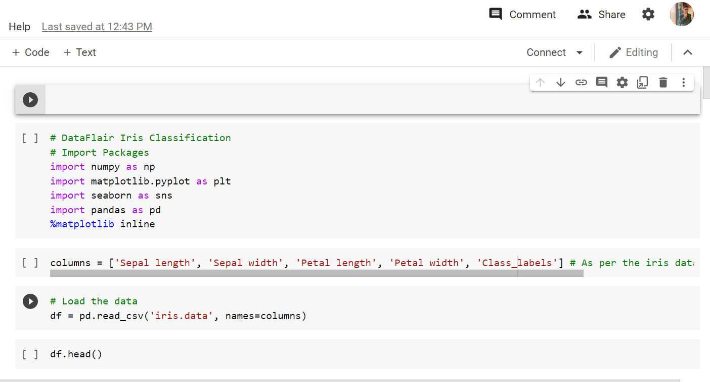

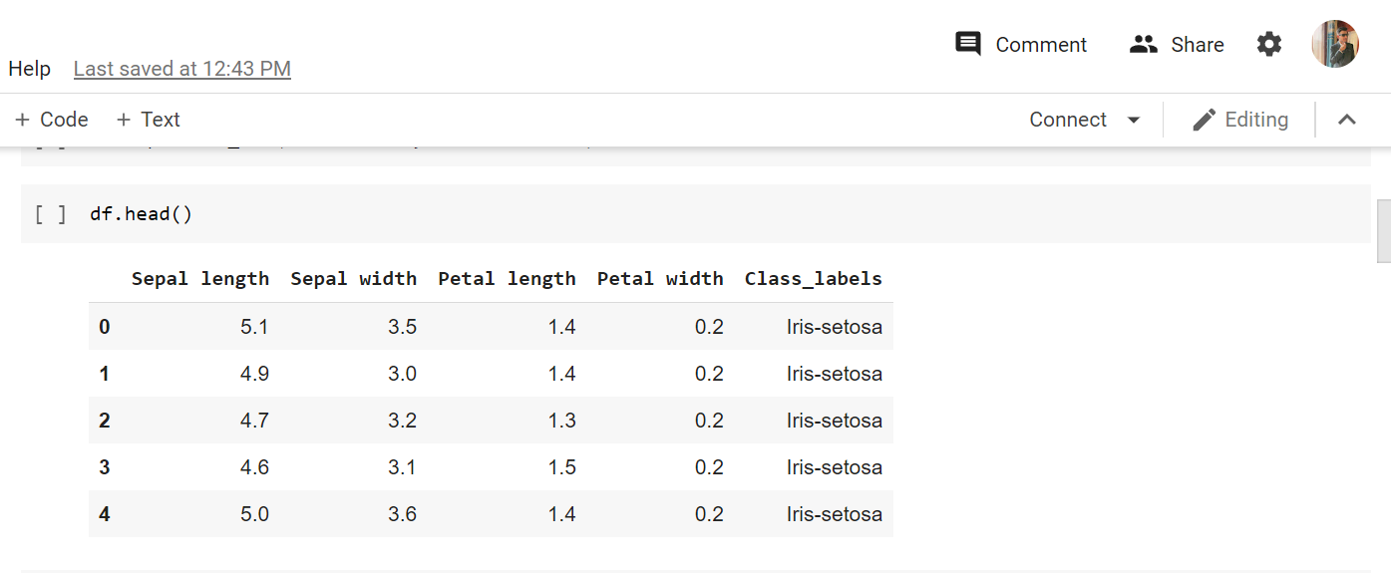

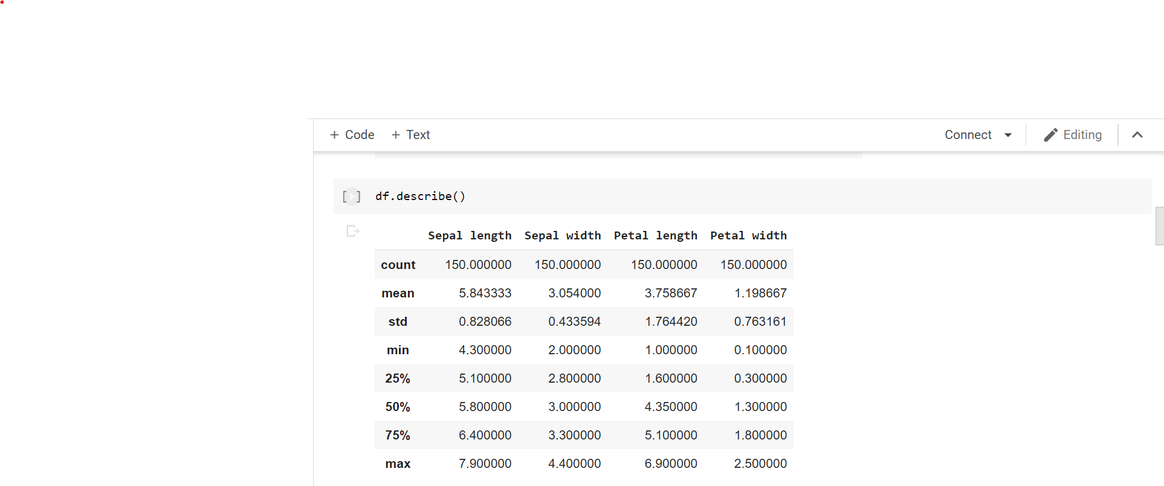 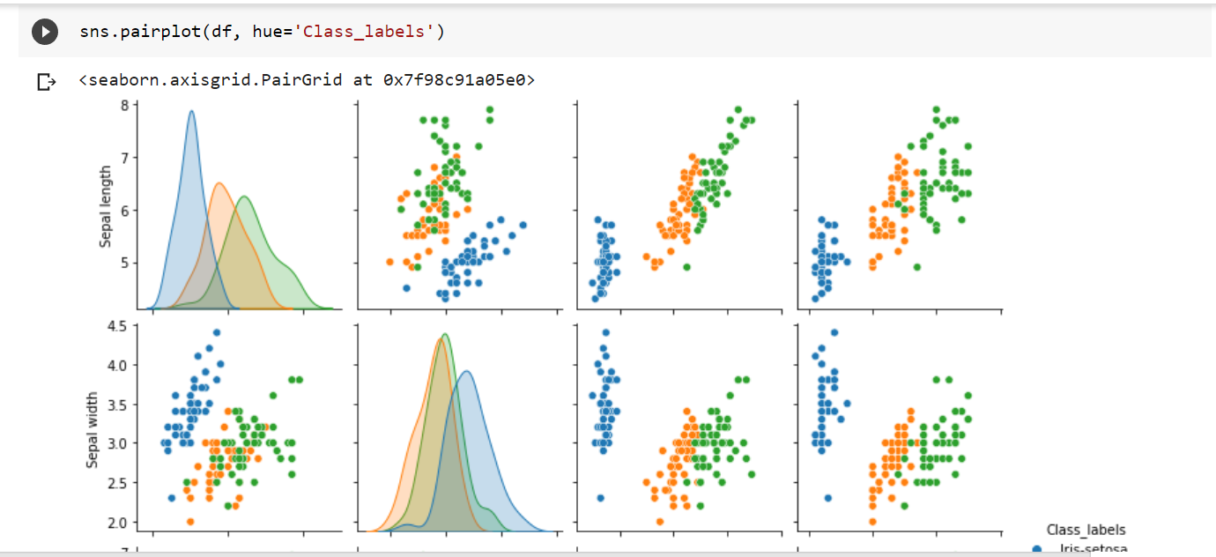 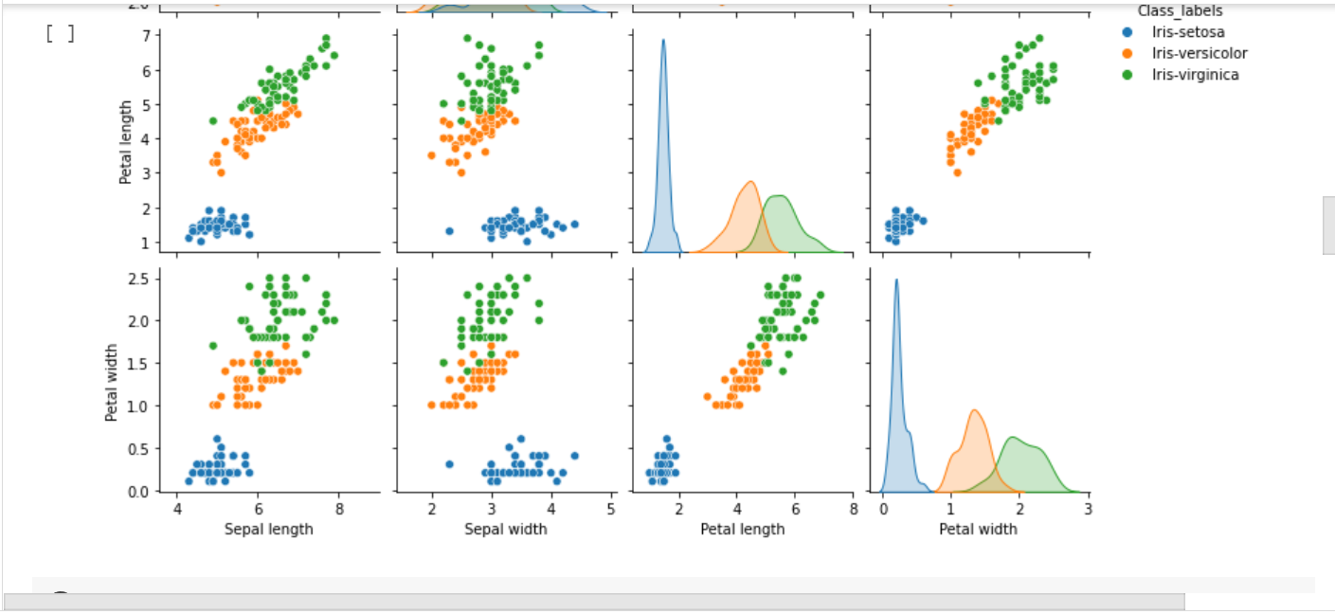 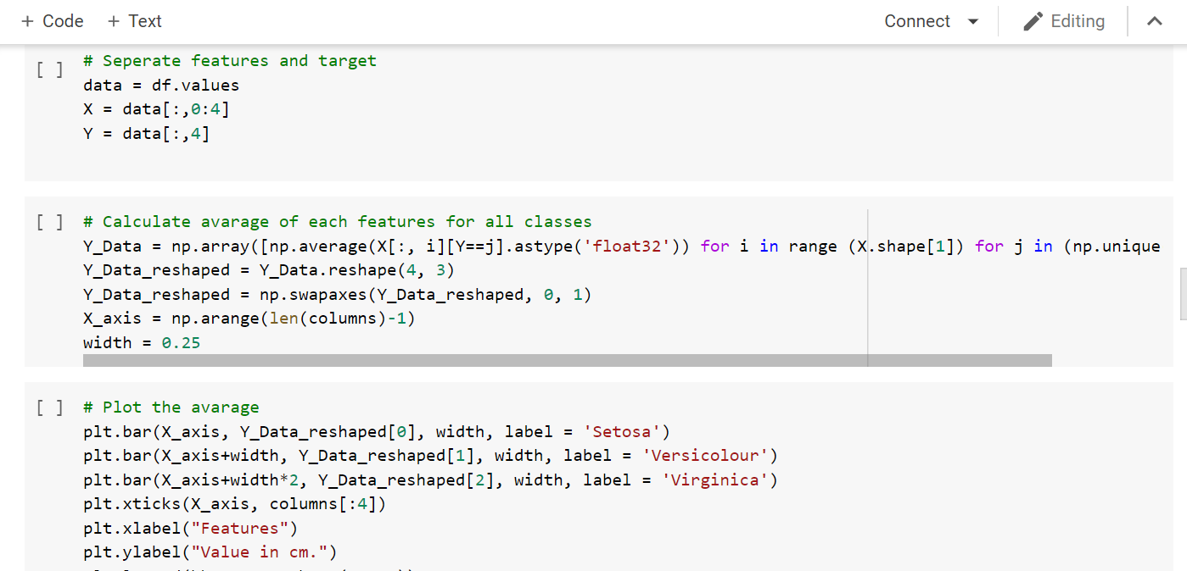 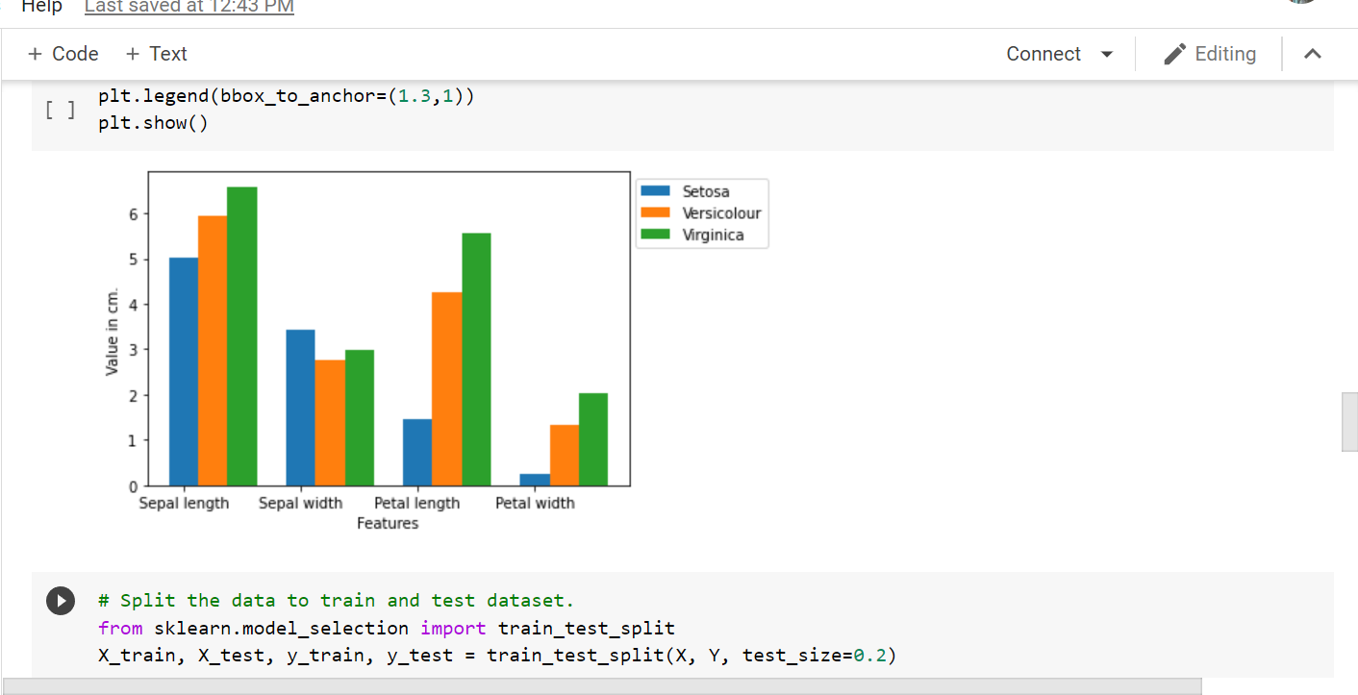 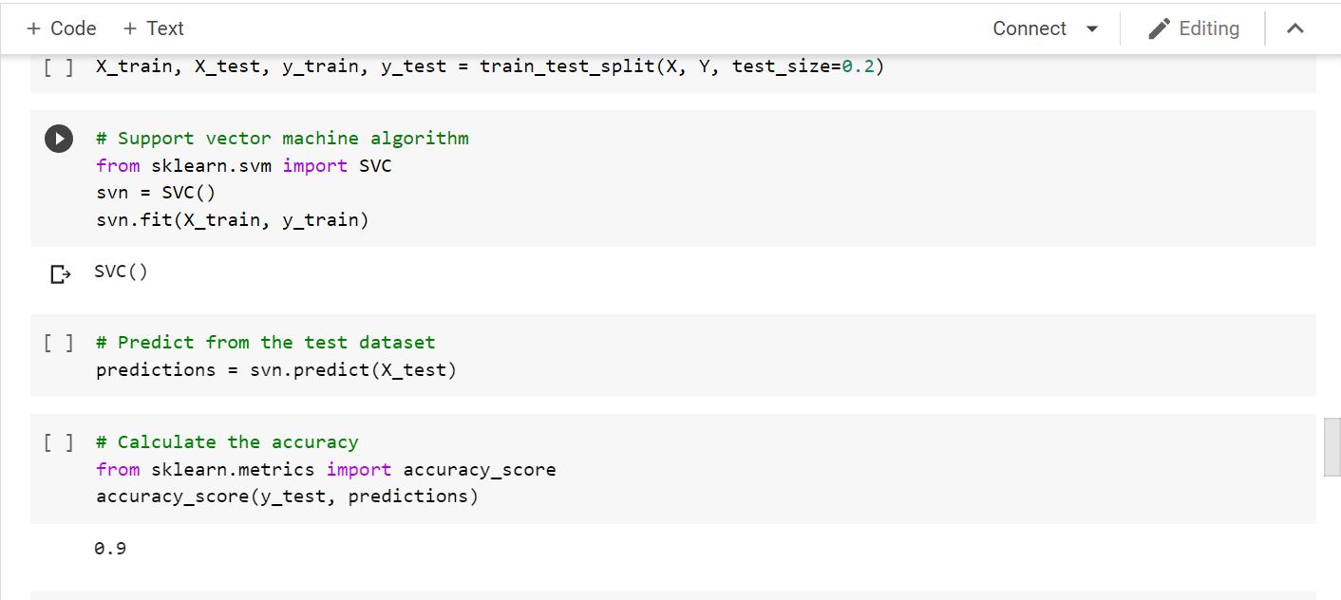 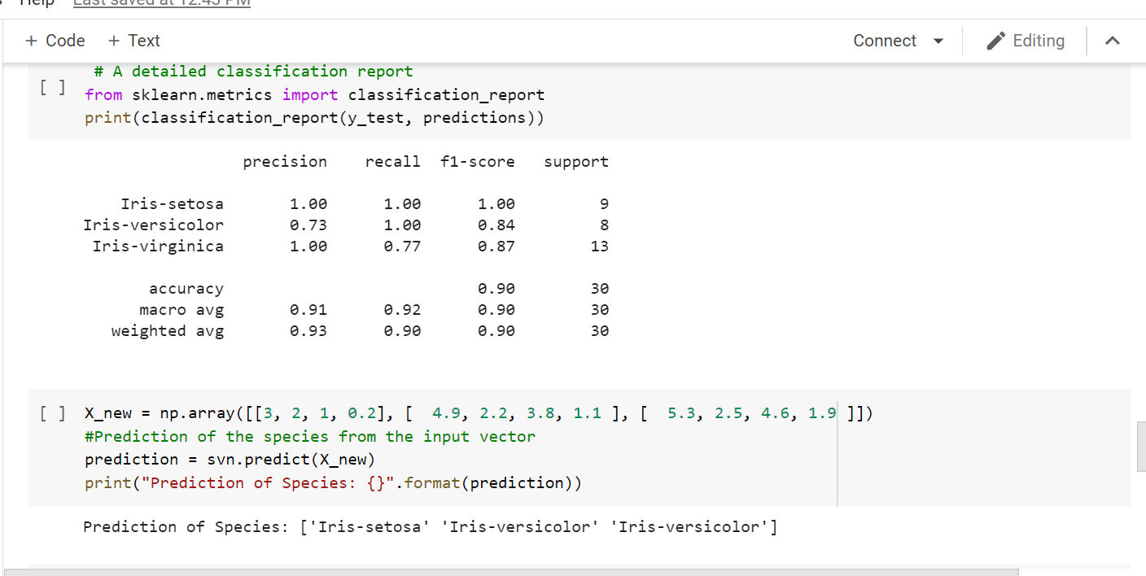

WITH THESE SCREENSHOTS OF MY CODES IN GOOGLE COLAB FOR IRIS CLASSIFICATION I HEREBY COME TO THE END OF THIS ML BASED PROJECT AND WOULD NOW START MY NEXT PART OF ASSIGNMENT.

PART 3:

1. STUDY ABOUT HAARCASCADE ALGORITHM.
2. TRY TO IMPORT HAARCASCADE ALGORITHM FOR FACE DETECTION IN IDE (.XML).
3. PREPARE A MODEL WHICH WILL DETECT THE FACE AND BOUNDARY IT USING GREEN COLOR BOX.

SOLUTION:- THE CODE OF THE PROJECT IS GIVEN BELOW:-



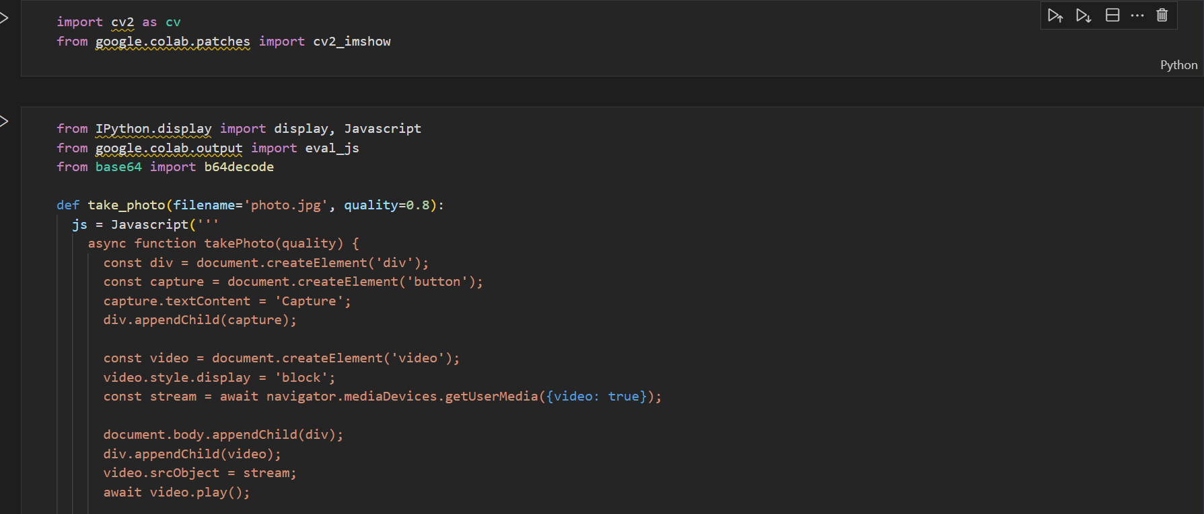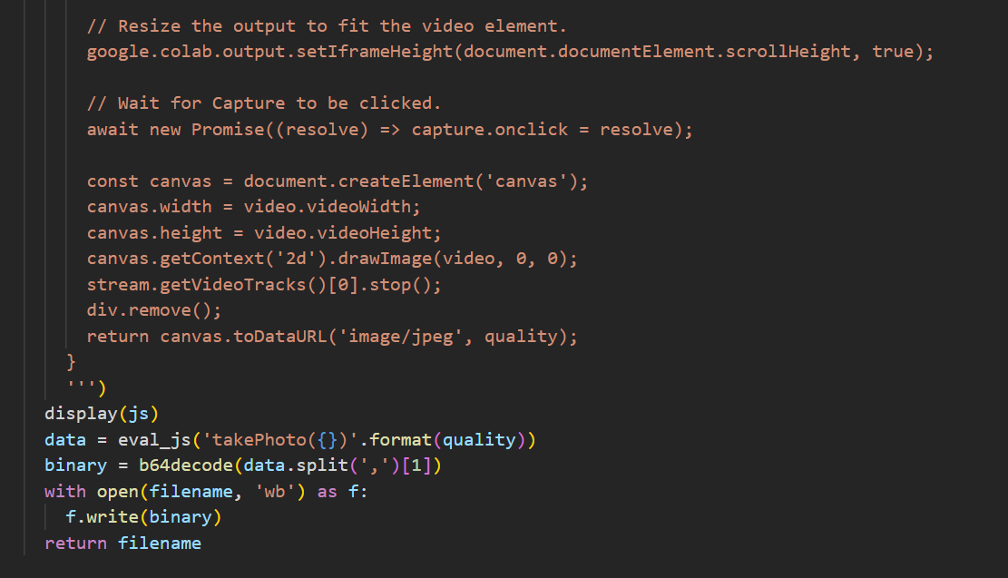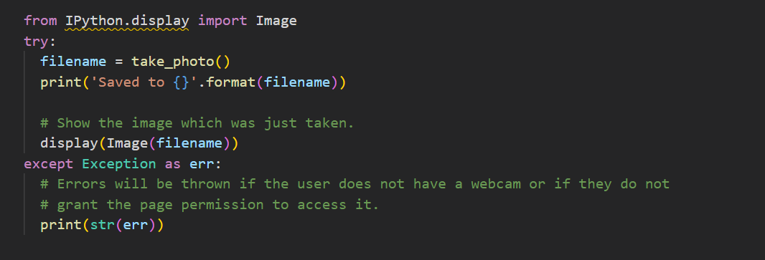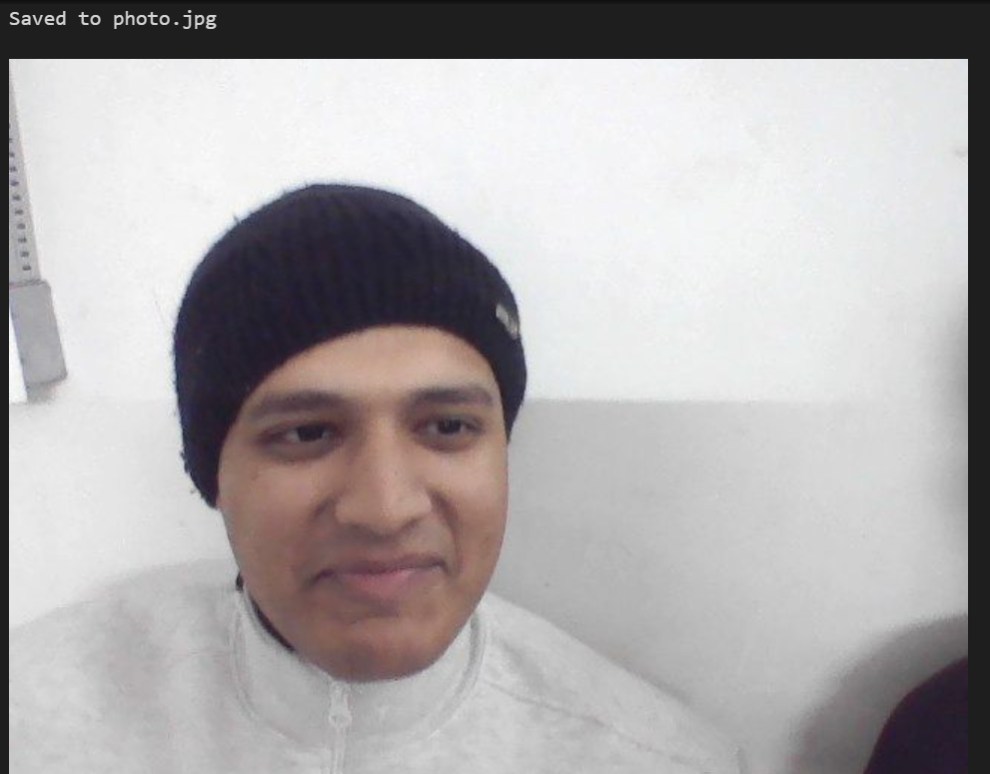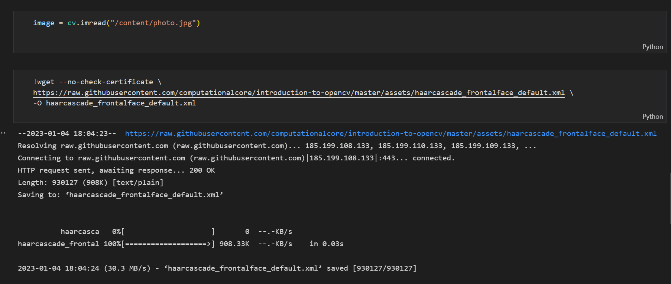

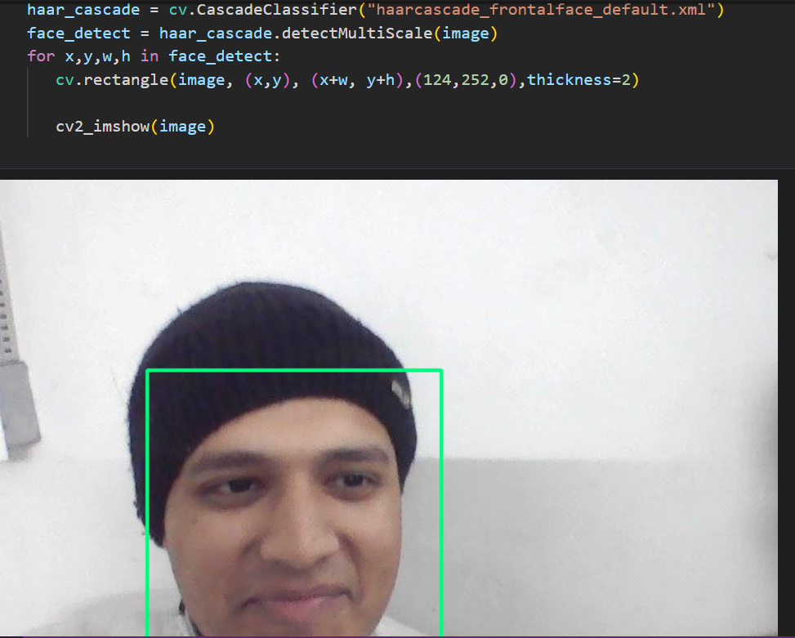

WITH THIS I COME TO AN END TO MY ASSIGNMENT THANK YOU FOR THIS WONDERFUL OPPORTUNITY.